In Loving Memory of

OWEN SWEENEY

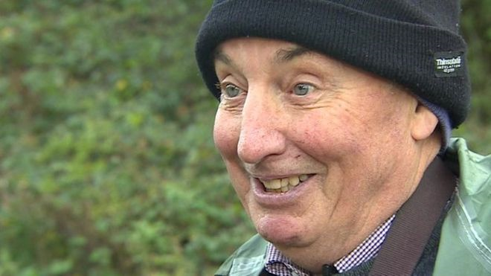

9 June 1943 – 9 February 2016

✝

Service at

St Thomas of Canterbury Church, Rainham

on

Wednesday 2 March 2016

at 14:00

Followed by Cremation at

Medway Crematorium, Chatham, ME5 9QU

**Order of Service**

**Reception and Procession**

**Welcome**

*Paul Sweeney, Owen’s son*

**Opening Hymn**

*I, the Lord of Sea and Sky*

I, the Lord of sea and sky,  
I have heard My people cry.  
All who dwell in dark and sin,  
My hand will save.  
I who made the stars of night,  
I will make their darkness bright.  
Who will bear My light to them?  
Whom shall I send?  
  
*Here I am Lord, is it I Lord?  
I have heard You calling in the night.  
I will go Lord, if You lead me.  
I will hold Your people in my heart.*  
  
I, the Lord of snow and rain,  
I have born my peoples pain.  
I have wept for love of them, They turn away.  
I will break their hearts of stone,  
Give them hearts for love alone.  
I will speak My word to them,  
Whom shall I send?  
  
*Here I am Lord, Is it I Lord?  
I have heard You calling in the night.  
I will go Lord, if You lead me.  
I will hold Your people in my heart.*  
  
I, the Lord of wind and flame,  
I will tend the poor and lame.  
I will set a feast for them,  
My hand will save  
Finest bread I will provide,  
Till their hearts be satisfied.  
I will give My life to them,  
Whom shall I send?  
  
*Here I am Lord, Is it I Lord?  
I have heard You calling in the night.  
I will go Lord, if You lead me.  
I will hold Your people in my heart.*

**Opening Prayer**

*Father Tom*

**Liturgy of the Word**

**Reading**

*Paul to the Philippians*

*Rev. Audrey Hayman, Owen’s sister-in-law*

**Psalm 145**

*Read by Roy Sweeney, Owen’s brother*

*Response:* *How good is the Lord to all*

The Lord is kind and full of compassion,   
slow to anger, abounding in love.   
How good is the Lord to all,   
compassionate to all his creatures  
  
*Response:* *How good is the Lord to all*

All your creatures shall thank you, O Lord,  
and your friends shall repeat their blessing.  
The eyes of all creatures look to you  
and you give them their food in due time.  
  
*Response: How good is the Lord to all*

The Lord is just in all his ways  
and loving in all his deeds.  
He is close to all who call him,  
who call on him from their hearts.

*Response:* *How good is the Lord to all*

**Gospel Reading**

*Father Tom*

**Homily**

**Bidding Prayers**

*Read by Josie Boxall*

**Offertory Music**

*Panis Angelicus*

**Liturgy of the Eucharist**

**Communion Hymn**

*Be Still, My Soul*

Be still, my soul; the Lord is on your side;

Bear patiently the cross of grief or pain;

Leave to your God to order and provide;

In every change he faithful will remain.

Be still, my soul; your best, your heavenly friend

Through thorny ways leads to a joyful end.

Be still, my soul; your God will undertake

To guide the future as he has the past.

Your hope, your confidence let nothing shake;

All now mysterious shall be bright at last.

Be still, my soul; the waves and wind still know

His voice who ruled them while he dwelt below.

Be still, my soul; though dearest friends depart

And all is darkened in the vale of tears;

Then you will better know his love, his heart,

Who comes to soothe your sorrows and your fears.

Be still, my soul; your Jesus can repay

From his own fullness all he takes away.

Be still, my soul; the hour is hastening on

When we shall be forever with the Lord,

When disappointment, grief, and fear are gone,

Sorrow forgot, love's purest joys restored.

Be still, my soul; when change and tears are past,

All safe and blessed we shall meet at last.

**Eulogy**

*Paul Sweeney, Owen’s son*

**Prayers of Commendation**

**Song of Farewell**

May the Choirs of Angels

*Sung by Linda Tapson*

**Recessional Hymn**

*How Great Thou Art*

O Lord my God! When I in awesome wonder

Consider all the works Thy hand hath made;

I see the stars, I hear the mighty thunder,

Thy pow'r throughout the universe displayed:

*Then sings my soul, my Saviour God, to Thee,*

*How great Thou art! How great Thou art!*

*Then sings my soul, my Saviour God, to Thee,*

*How great Thou art! How great Thou art!*

When through the woods and forest glades I wander

And hear the birds sing sweetly in the trees;

When I look down from lofty mountain grandeur,

And hear the brook, and feel the gentle breeze:

*Then sings my soul, my Saviour God, to Thee,*

*How great Thou art! How great Thou art!*

*Then sings my soul, my Saviour God, to Thee,*

*How great Thou art! How great Thou art!*

And when I think that God, His Son not sparing,

Sent Him to die - I scarce can take it in:

That on the Cross, my burden gladly bearing,

He bled and died to take away my sin:

*Then sings my soul, my Saviour God, to Thee,*

*How great Thou art! How great Thou art!*

*Then sings my soul, my Saviour God, to Thee,*

*How great Thou art! How great Thou art!*

When Christ shall come with shout of acclamation

And take me home - what joy shall fill my heart!

Then shall I bow in humble adoration,

And there proclaim, my God how great Thou art!

*Then sings my soul, my Saviour God, to Thee,*

*How great Thou art! How great Thou art!*

*Then sings my soul, my Saviour God, to Thee,*

*How great Thou art! How great Thou art!*

**Medway Crematorium**

Vincent (Starry Starry Night) – *Don McLean*

**Service**

Edited Highlights of Nightingales recorded at Lodge Hill

Nightingale Song

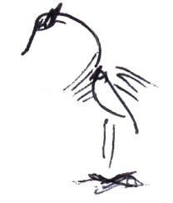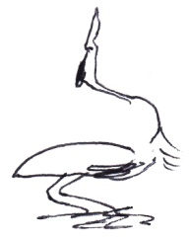

Owen’s family would like to thank you for your attendance today and for the kind messages of sympathy and support they have received.

You are warmly invited to join the family for refreshments and to share your memories of Owen after the service at:

The Robin Hood Pub

364 Common Road

Blue Bell Hill

Chatham

ME5 9RJ

Donations, if desired, to either

Wisdom Hospice, Rochester

or

Kent Wildlife Trust

in memory of Owen Sweeney.

These can be sent to:

John Weir Funeral Directors

c/o Julia Stevens

31 Parkwood Green

Rainham

Kent

ME8 9PW

01634 386999